2200031128 CH BHAVANA
HandsOn TASK 2 :
Create a react app for Student Management Portal named StudentApp and create a component named Home which will display the Message “Welcome to the Home page of Student Management Portal”. Create another component named About and display the Message “Welcome to the About page of the Student Management Portal”. Create a third component named Contact and display the Message “Welcome to the Contact page of the Student Management Portal”. Call all the three components.
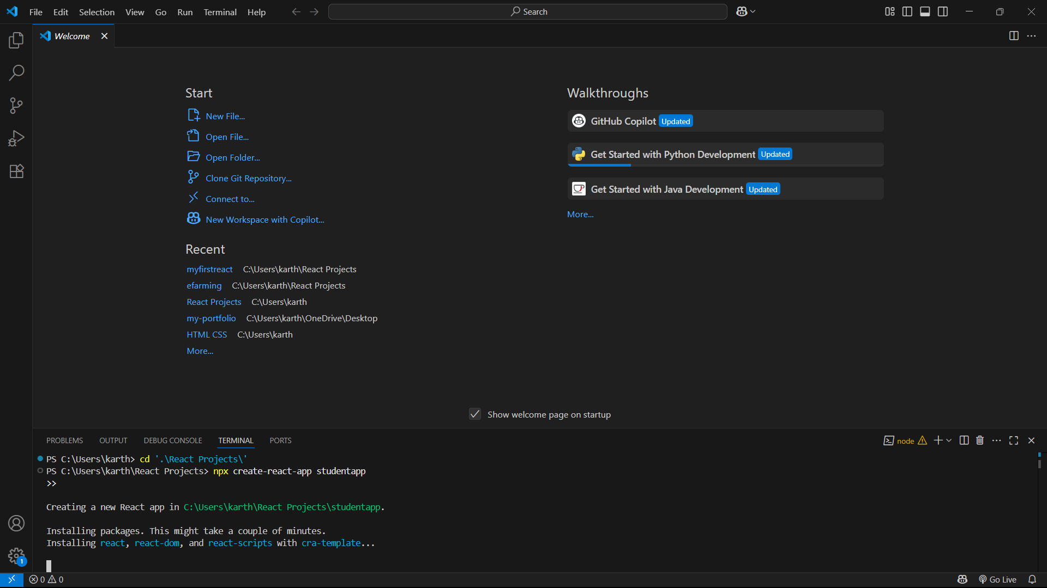
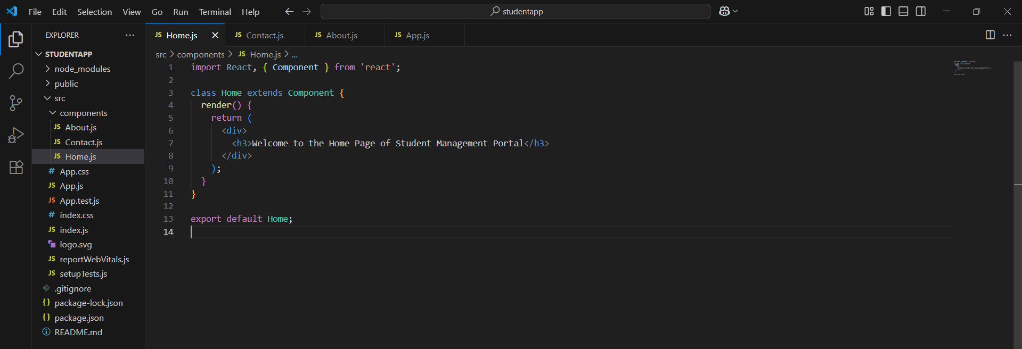
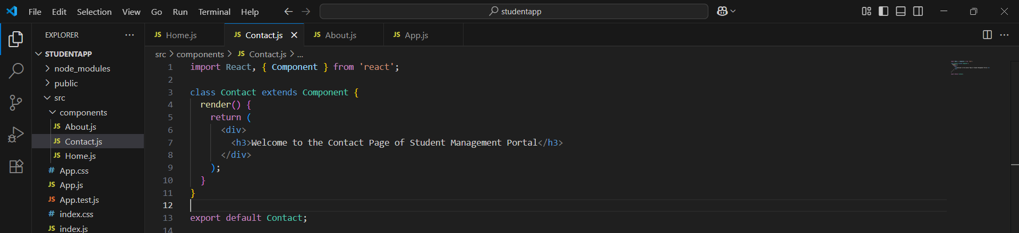
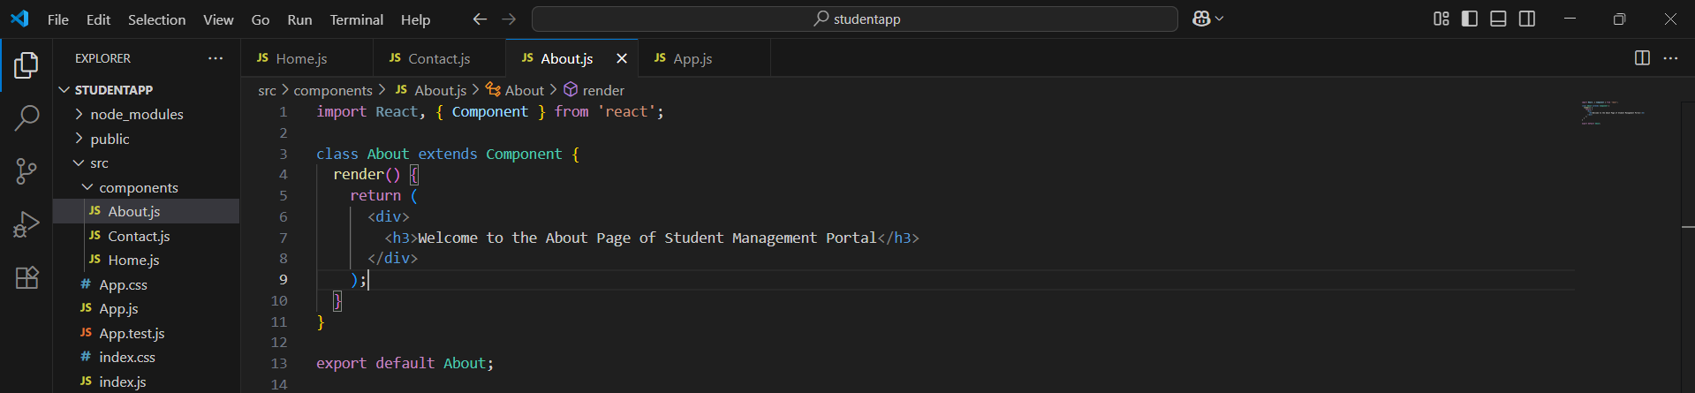
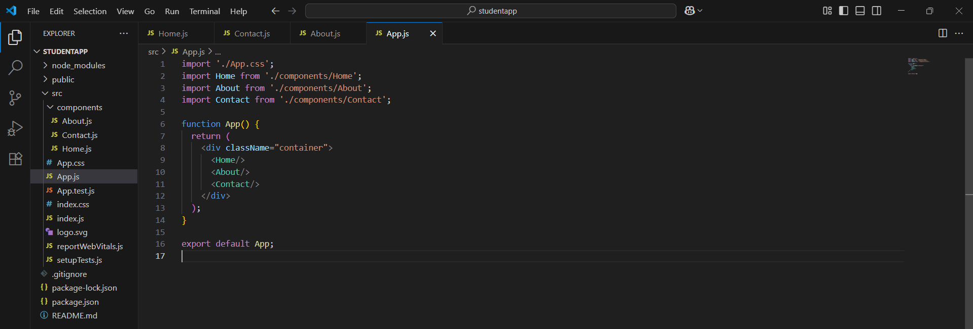
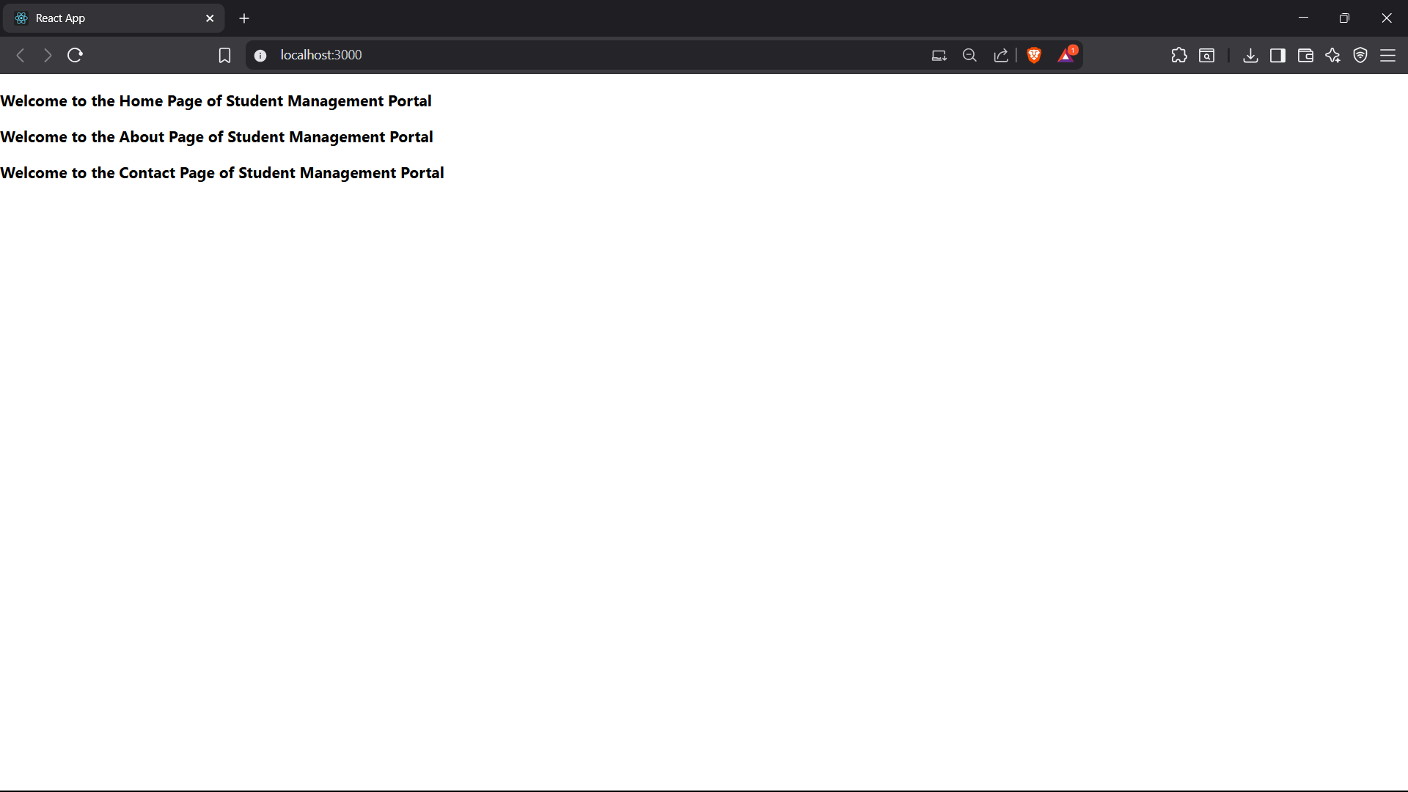

🧱 Step 1: Install/Create React App
- Why: To start a new project using React
- What:
npx create-react-app studentapp
→ Sets up all required files and libraries for a working React project

📂 Step 2: Enter the Project & Start
- Why: To run and see your project in the browser
- What:
cd studentapp → goes inside your project folder
npm start → runs the project at localhost:3000

🗂️ Step 3: Create a “Components” Folder
- Why: To organize your custom components
- What:
Inside src, create a folder called Components for storing Home, About, Contact components

🧩 Step 4: Create Component Files
- Why: To define parts of your app separately
- What:
Create Home.js, About.js, and Contact.js
Each one returns a message inside a <div> using a class component

🔁 Step 5: Import Components in App.js
- Why: To use all 3 components in one place
- What:
Use import to bring in the components
Use <Home />, <About />, <Contact /> inside the return statement

🚀 Step 6: Run App Again
- Why: To check if all components are showing
- What:
Run npm start again → You’ll see all three messages on the page

